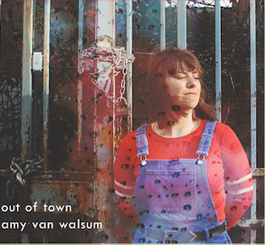
- Out of Town (Rachel Leach)
- Destroying Beauty (Tansy Davis)
- Greeting (Rebecca Clark)
- Shy One (Rebecca Clark)
- A Suite O’Bairnsangs (Thea Musgrave)
i. A Bairns Prayer at Night
ii. The Gean
- The Old Woman at the Flower Show (Elaine Hugh-Jones)
- Ophelia’s Song (Elizabeth Maconchy)
- Remember or Forget (Ethel Barns)
- Five Betjeman Songs (Madeleine Dring)
i. A Bay in Anglesey
ii. Song of a Nightclub Proprietress
iii. Business Girls
iv. Undenominational
v. Upper Lambourne
Amy van Walsum
Out of Town
Released: April 10th 2019
- II Romeo (Barbara Strozzi)
- I Baci (Barbara Strozzi)

Out of Town is the debut album from Dutch soprano Amy Van Walsum. Having previously collaborated with renowned composers Andrew Toovey, Fumiko Miyachi and Michael Wolters. In addition to performing in the physics opera Entanglement! An entropic tale by Infinite Opera Company, Van Walsum creates an ambitious work performing music solely by female composers.
Whether it’s performing some of the most exciting voices working in composition today or raising a platform to underappreciated composers of yesteryear, this record shows the first stages of Van Walsum’s manifesto of making visible some of the unreported, yet equally rich, world of female composers. The diversity on this record includes compositions from early music pioneer Barbara Strozzi, the melancholic Ophelia’s song by Elizabeth Maconchy and Madeleine Dring’s musical settings of Betjeman poems.
Currently based at Royal Birmingham Conservatoire, an institution renounced for its embrace of contemporary music, several selections of this record have been devoted to modern composers, most notably with Tansy Davis and Thea Musgrave. Recorded in the conservatoires recital hall; known for its rich acoustics along and built-in technology, this recording excels in showing these compositions at their best.
What Out of Town aims to achieve is to inspire fellow singers to perform contemporary music as well as highlighting the various depths that modern music can reach.

